df1 - banner
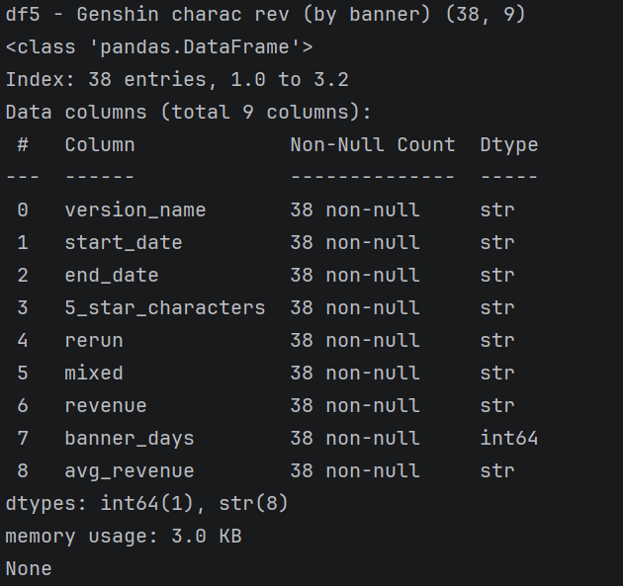
0: Game version: 1 - 3.2
1: banner start date
2: banner end date
3: Characters
4: 有沒有rerun
5: rerun時有沒有新角色(有時會2者一起計算revenue)
6: 總營收
7: banner days
8: 平均營收

df2

df2_0-11 Main Data (NaN in 5Col.)
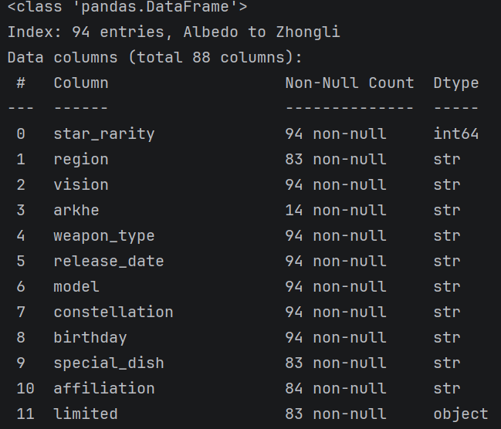
index: Name
0: 5/4星角色
print(df2.star_rarity.value_counts())
1: 角色所屬地區 - 11NaN = Player
print(df2.region.value_counts())
2: 屬性
print(df2.vision.value_counts()) ###屬性分類做PIE CHART
3. 特殊能力 - 稀有角色持有
print(df2.arkhe.value_counts())
4. 武器種類
print(df2.weapon_type.value_counts())
5. 登場日期 (sort來睇version), 先sort 再1+2, 再用剩下角色merge其他
6. 模型歸類 (角色人氣相關)
print(df2.model.value_counts())
7.
print(df2.constellation.value_counts())
8. 出生日期
9. 煮飯能力(特殊能力) - 11NaN = Player
10.
11. 限定角色
print(df2.limited.value_counts())

NaN
print(df2[df2['region'].isna()])
print(df2[df2['arkhe'].isna()]) ####除了利用地圖能量塊，楓丹本地角色與水元素旅行者的技能中皆內建了特定的始基力屬性,
print(df2[df2['special_dish'].isna()]) ####雷電將軍因為角色設定「不會做飯」, 還有就是PLAYER
print(df2[df2['affiliation'].isna()])
print(df2[df2['limited'].isna()])

df2_12-15: Voice
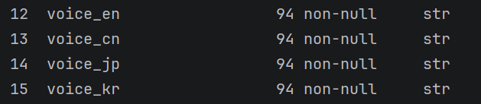
df2_voice = df2.filter(like="voice").columns.tolist() ###聲優
# print(df2_voice)

df2_16-24: 突破素材 (NaN in Col.17)
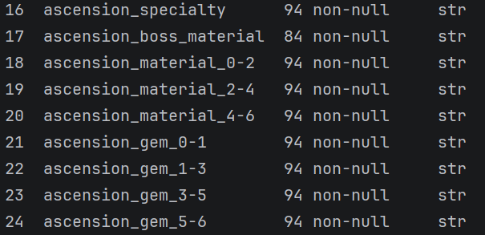
10 Nan
print(df2[df2['ascension_boss_material'].isna()])

df2_ascension = df2.filter(like="ascension").columns.tolist()
# print(df2_ascension)
df2_a_material = df2[['ascension_specialty',
'ascension_boss_material', 'ascension_material_0-2', 'ascension_material_2-4', 'ascension_material_4-6',
'ascension_gem_0-1', 'ascension_gem_1-3', 'ascension_gem_3-5', 'ascension_gem_5-6']] ####突破素材
# print(df2_a_material)

df2_25-37: 技能素材
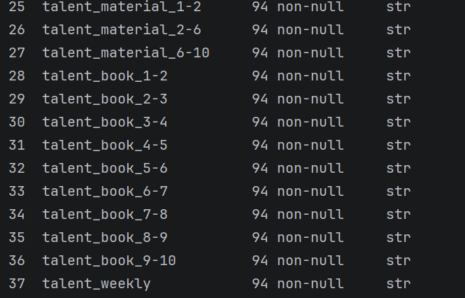

df2_talent = df2.filter(like="talent").columns.tolist()
# print(df2_talent)
df2_t_material = df2[['talent_material_1-2', 'talent_material_2-6', 'talent_material_6-10',
'talent_book_1-2', 'talent_book_2-3', 'talent_book_3-4', 'talent_book_4-5', 'talent_book_5-6', 'talent_book_6-7', 'talent_book_7-8', 'talent_book_8-9', 'talent_book_9-10',
'talent_weekly']] ####突破素材
# print(df2_t_material)

df2_38-79: Character Status
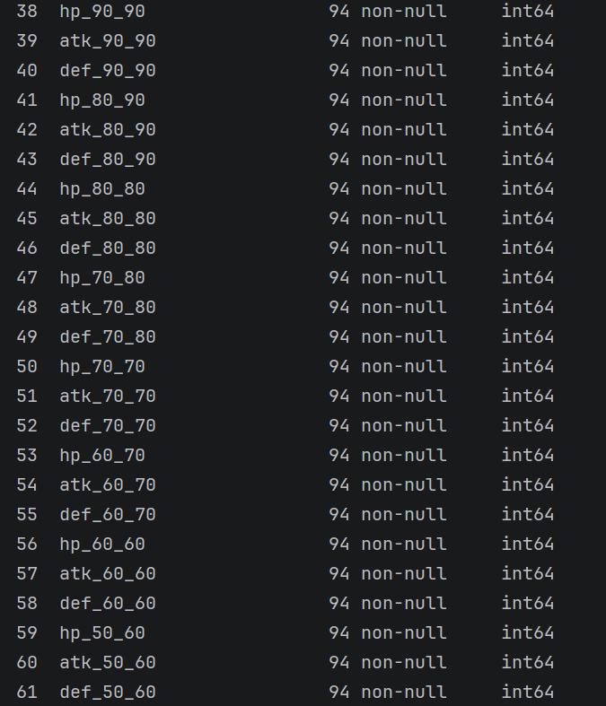
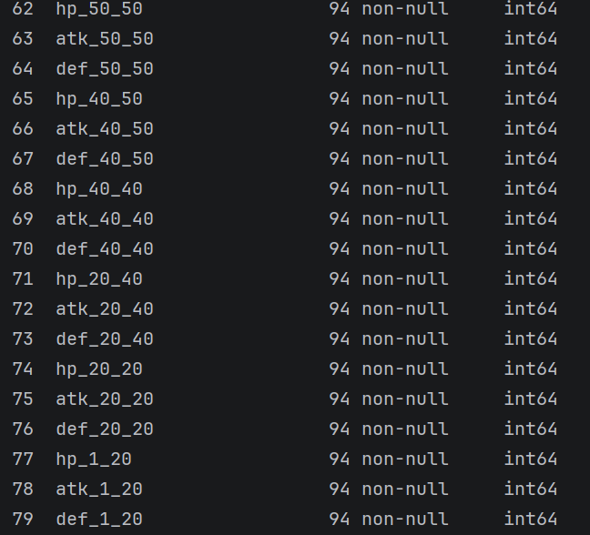

df2_atk = df2.filter(like='atk')
# print(df2_atk)
df2_hp = df2.filter(like='hp')
# print(df2_hp)
df2_def = df2.filter(like='def')
# print(df2_def)
df2_status = df2_atk + df2_hp + df2_def ###Character status
# print(df2_status)

df2_80-87: 突破能力Bonus
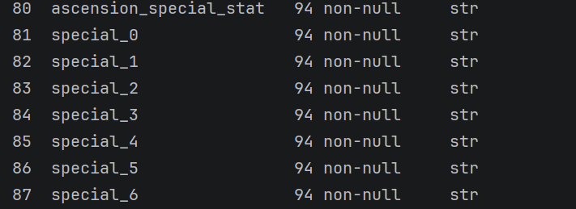
80是突破後BONUS一個能力加成項目
81-87分別指出不同突破階段的加成率

df2_special = df2.filter(like="special").columns.tolist()
# print(df2_special)
df2_Ascension_status = df2[['ascension_special_stat', 'special_0', 'special_1', 'special_2', 'special_3', 'special_4', 'special_5', 'special_6']] ####突破BONUS
# print(df2_Ascension_status)

df3 - 人氣 (NaN in 7Col.)
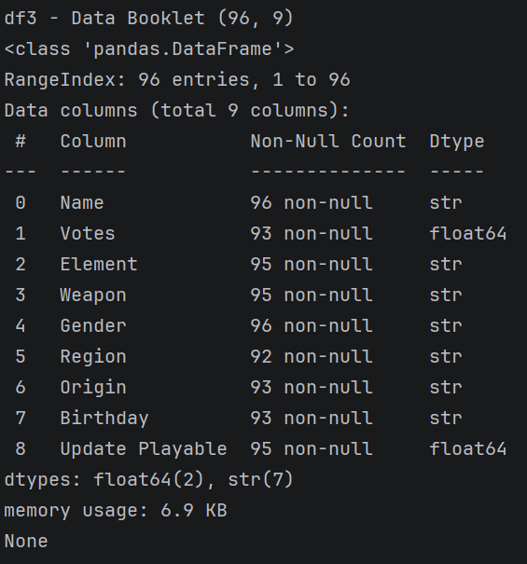
0: Name
1: 人氣投票
2:
3: 武器
4: 性別
5: 角色所屬地區
6:
7: 出生日期
8: Game version: 1 - 5.4

print(df3[df3['Votes'].isna()])
print(df3[df3['Element'].isna()])
print(df3[df3['Weapon'].isna()])
print(df3[df3['Region'].isna()])
print(df3[df3['Origin'].isna()])
print(df3[df3['Birthday'].isna()])
print(df3[df3['Update Playable'].isna()])

df4 - 能力
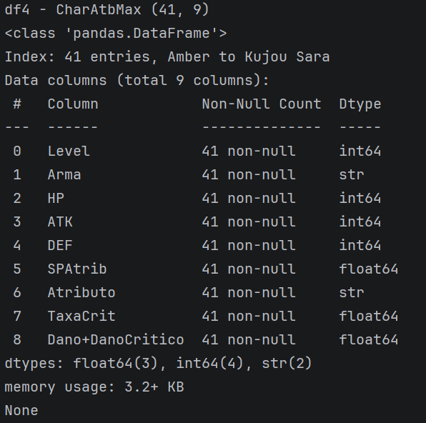
0: Level
1: 屬性
2: HP
3: ATK
4: DEF

5: 專屬突破屬性
6: 角色專有BONUS加成 (index)(extra
7: 會心率
8: 會心傷害倍率

df5 - character
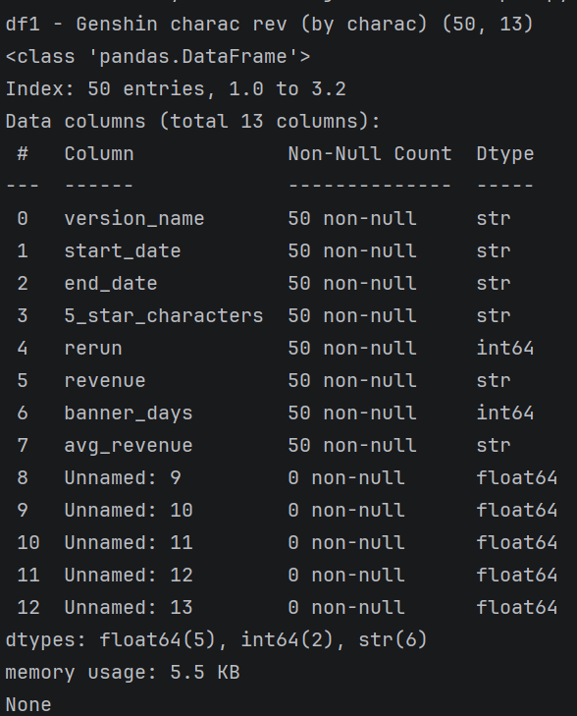
0: Game version: 1 - 3.2
1: banner start date
2: banner end date
3: Characters
4: 有沒有rerun
5: 總營收
6: banner days
7: 平均營收
8 - 12: No entries

分頁 12
- 時間軸
- 金錢 (Marketing)
- 2個相關比較(如國家/公司)

邊做方向邊搵DATA調整
即可以先搵DATA定方向/ 先諗方向再搵DATA, 2者間交互

